LAB EXPERIMENT RECORD
SET 6: PRODUCT SALES ANALYSIS
Department | AI & DS
Course Code / Course Name | DSA0602 / Data Handling and Visualization
Experiment | Data Visualization using R
Name | M.Teja kumar
Register Number | 192424308
Date | 01 October 2026
Day | Thursday
SET 6: PRODUCT SALES ANALYSIS
Dataset: Monthly Product Sales
Product ID | Product Name | January Sales | February Sales | March Sales
1 | Product A | 2000 | 2200 | 2400
2 | Product B | 1500 | 1800 | 1600
3 | Product C | 1200 | 1400 | 1100
PROGRAM 1: Product Sales - First Quarter
Create a grouped bar chart to visualize the sales of each product for the first quarter. Label the chart elements.
# Dataset
product_id <- c(1, 2, 3)
product_name <- c("Product A", "Product B", "Product C")
january <- c(2000, 1500, 1200)
february <- c(2200, 1800, 1400)
march <- c(2400, 1600, 1100)
sales <- data.frame(
product_id = product_id,
product_name = product_name,
January = january,
February = february,
March = march
)
sales_matrix <- t(as.matrix(sales[, 3:5]))
barplot(sales_matrix,
beside = TRUE,
names.arg = sales$product_name,
main = "Product Sales - First Quarter",
xlab = "Product",
ylab = "Sales",
legend.text = c("January", "February", "March"))
Output 1: Product Sales - First Quarter
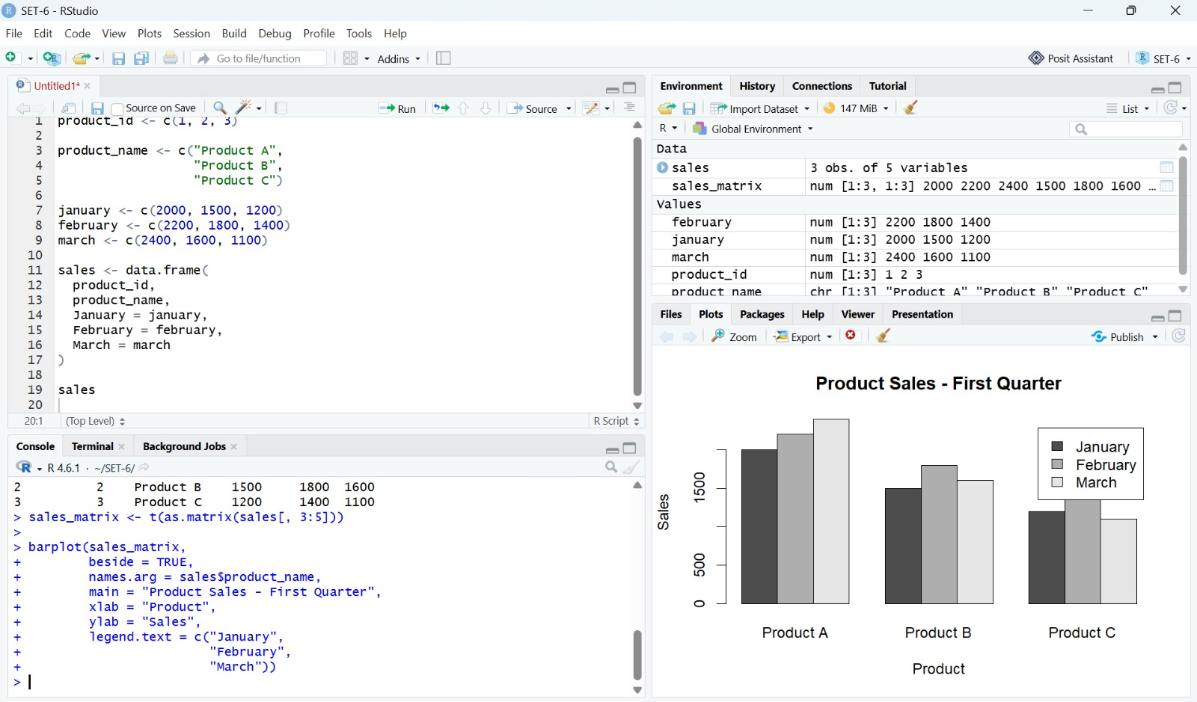
Observation: The grouped bar chart compares January, February, and March sales for Products A, B, and C.
PROGRAM 2: Overall Product Sales Trend
Generate a stacked area chart to represent the overall sales trend for all products over the three months.
# Overall Product Sales Trend
plot(sales_matrix[1, ],
type = "n",
xaxt = "n",
main = "Overall Product Sales Trend",
xlab = "Month",
ylab = "Sales")
polygon(c(1:3, rev(1:3)),
c(sales_matrix[1, ], rev(rep(0, 3))),
col = "lightblue")
polygon(c(1:3, rev(1:3)),
c(sales_matrix[1, ] + sales_matrix[2, ],
rev(sales_matrix[1, ])),
col = "orange")
polygon(c(1:3, rev(1:3)),
c(sales_matrix[1, ] + sales_matrix[2, ] + sales_matrix[3, ],
rev(sales_matrix[1, ] + sales_matrix[2, ])),
col = "lightgreen")
axis(1, at = 1:3, labels = c("January", "February", "March"))
legend("topleft",
legend = c("Product A", "Product B", "Product C"),
fill = c("lightblue", "orange", "lightgreen"))
Output 2: Overall Product Sales Trend
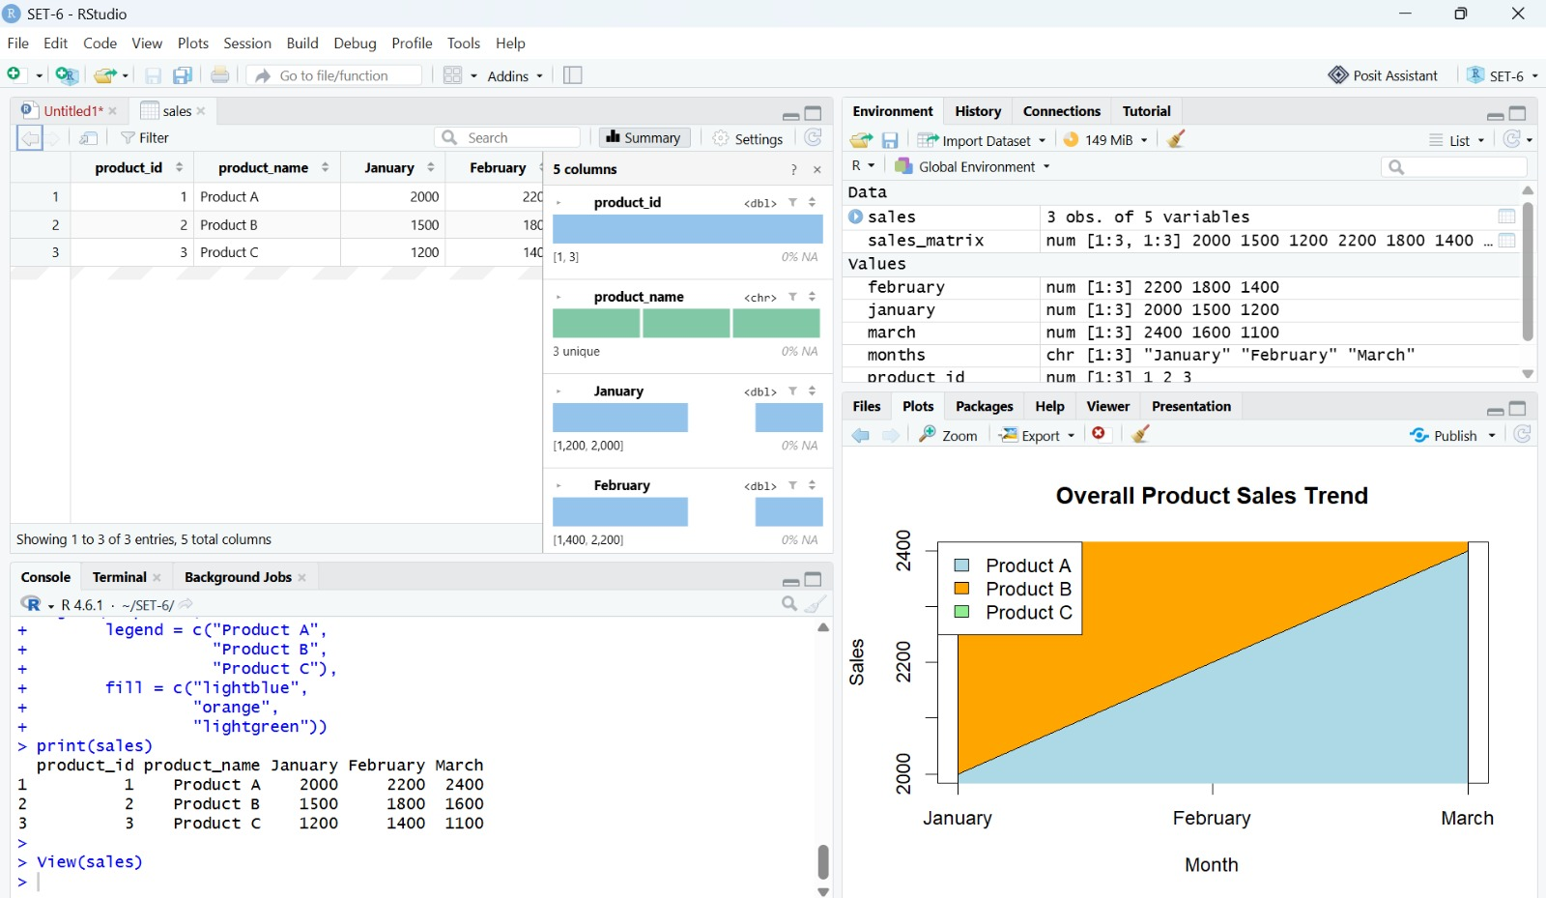
Observation: The stacked area chart represents the combined monthly sales contribution of Products A, B, and C.
PROGRAM 3: Monthly Sales Data Table
Build a table to show the monthly sales data for each product. Label the table elements.
Product ID | Product Name | January Sales | February Sales | March Sales
1 | Product A | 2000 | 2200 | 2400
2 | Product B | 1500 | 1800 | 1600
3 | Product C | 1200 | 1400 | 1100
Output 3: Monthly Sales Data Table
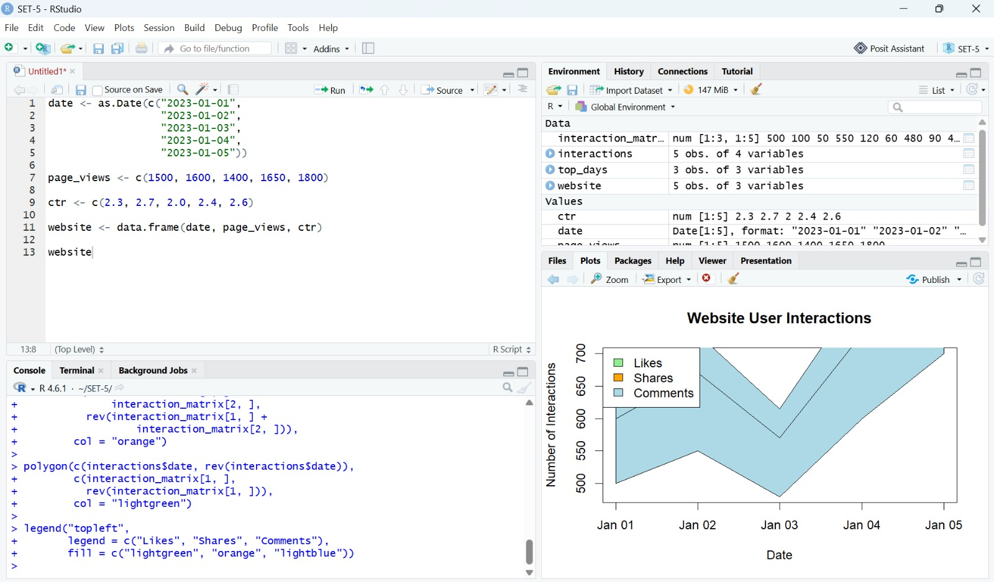
Observation: The table presents the January, February, and March sales values for each product.
PROGRAM 4: Tableau Dashboard
Develop a Tableau dashboard combining the grouped bar chart, stacked area chart, and the table for interactive exploration of sales data.
Set 6 Procedure
1. Create the monthly sales data for Products A, B, and C.
2. Convert the monthly sales columns to a matrix and use barplot() with beside = TRUE for the grouped bar chart.
3. Use the monthly sales values to construct the stacked area chart.
4. Display the monthly sales values in a table.
5. Combine the grouped bar chart, stacked area chart, and table as the visualizations for the Tableau dashboard.
Set 6 Result
The monthly product sales data was visualized using a grouped bar chart, stacked area chart, and a table.

